Lucidchart is a diagramming solution for UML with deep integration with third-party apps. Make the diagram itself in Lucidchart, and create your use case scenario document with a program like Google Docs!

3 min read

Want to make a UML diagram of your own? Try Lucidchart. It's quick, easy, and completely free.

Top of Form

Make a UML diagram

By registering I agree to Lucid Software's [Terms of Service](https://www.lucidchart.com/pages/tos) and [Privacy Policy](https://www.lucidchart.com/pages/privacy).

Bottom of Form

**What is a use case diagram in UML?**

A use case collects scenarios. By writing out the main parts of your process, including alternative paths, you’ll have a clearer outlook on the scope of your project. Although you can copy and paste text and make simple edits in the Lucidchart editor, you may want to first write your use case scenario in a program like Google Docs. The [Lucidchart add-on for Google Docs](https://chrome.google.com/webstore/detail/lucidchart-diagrams/klhpiejgjijjcglpcaanggahphcgckpm?hl=en) is an ideal solution for bringing together the visual diagramming and written aspects of project management.

**Outline your use case diagram**

Use case scenario documents break down a process by describing the actors, the typical workflow, and the things that could go wrong, called extensions. When managing projects that use UML conventions, there can be a temptation to jump straight into the use case diagram, with stick figures, ovals, and lots of lines. But if you don’t know your goals and who’s involved, take a step back and write your goals down in prose. [Alistair Cockburn](http://alistair.cockburn.us/Use+cases) is a leader in designing use case scenarios; visit his website to get inspired!

This is a brief example the process of withdrawing money from an ATM. The outline goes through each of the steps that are likely to occur in the process, including each of the errors that could likely occur. Outlining the process like this will help you to outline the process, making the act of diagramming your use case scenario easier than ever.

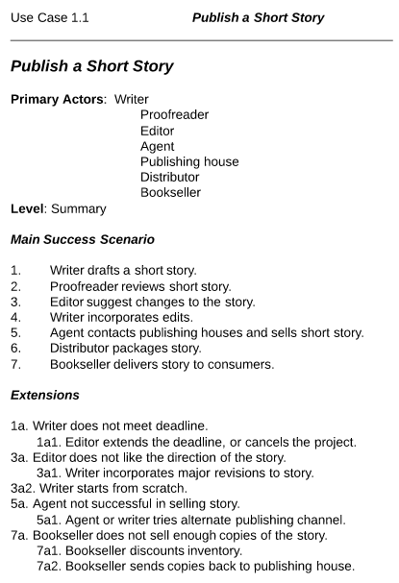

Diagramming is quick and easy with Lucidchart. Start a free trial today to start creating and collaborating.

Top of Form

Make a UML diagram

By registering I agree to Lucid Software's [Terms of Service](https://www.lucidchart.com/pages/tos) and [Privacy Policy](https://www.lucidchart.com/pages/privacy).

Bottom of Form

**Use case diagram examples in Lucidchart**

Use case diagrams are visual representations of written use case scenarios. Once you’ve hammered out the kinks in your goals, use Lucidchart to diagram the interactions between the use cases and actors to write the success story for your project. The drag-and-drop interface is responsive and easy to learn. Lucidchart comes populated with an extensive shape library for every UML diagram type, including activity diagrams, class diagrams, and use case diagrams.

**Book publishing use case diagram example**

This use case diagram is a visual representation of the prose scenario shown above. Whether you’re an author, an agent, or a bookseller, inserting this diagram into your use case scenario can help your team publish the next big hit. [Try our demo template](https://www.lucidchart.com/documents/editNewOrRegister/d57da15a-8cc8-4c3d-bec2-95bf074635d5/0) for a book publishing use case diagram here.

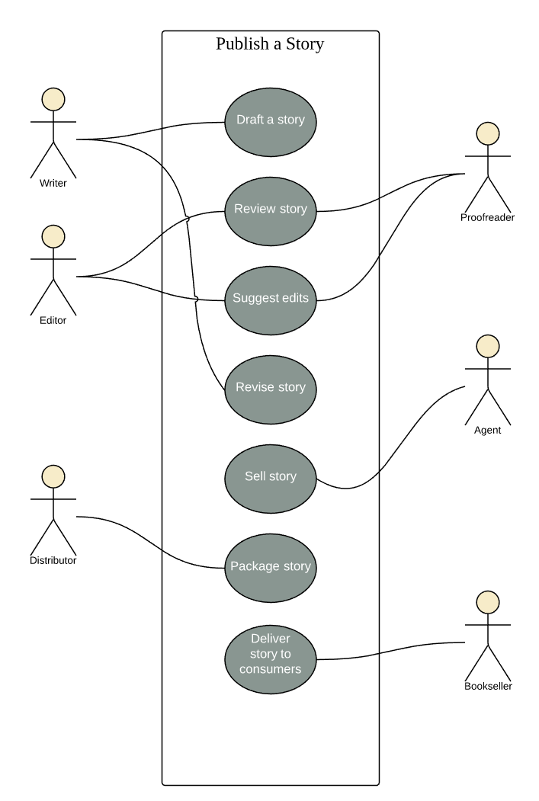

**Railway reservation use case diagram example**

This customizable template can be adapted for any process where a customer is purchasing a service. With attractive color schemes, text that’s easy to read and edit, and a wide-ranging UML shape library, you’re ready to go! Jump right in and [try our demo template](https://www.lucidchart.com/documents/editNewOrRegister/6641f344-e2ce-4138-a2c8-7fad5ad13fb2/) to get started.

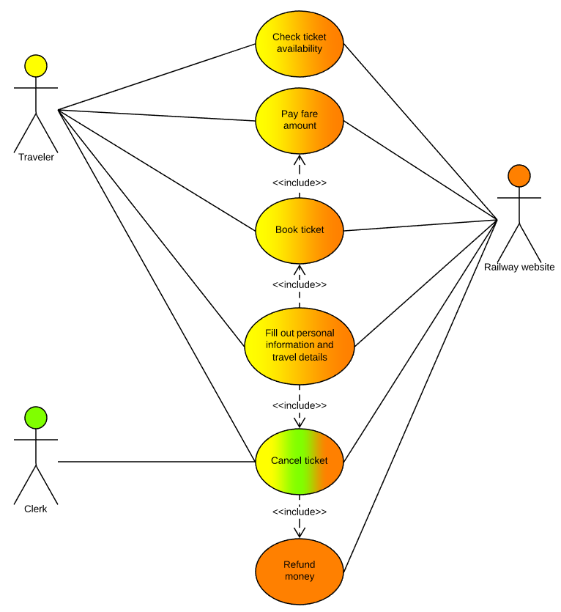

**Banking system use case diagram example**

Modern banking systems need to have clear objectives. This diagram presents a high-level overview of some of the most fundamental goals a customer has with his or her bank—opening an account, checking a balance, and withdrawing money. If you like this template [try i](https://www.lucidchart.com/documents/demo/aa974d61-6a50-440b-b05e-14f1991b3d1e/)[t out in Lucidchart](http://www.lucidchart.com/documents/demo/aa974d61-6a50-440b-b05e-14f1991b3d1e/) for a banking system use case diagram here.

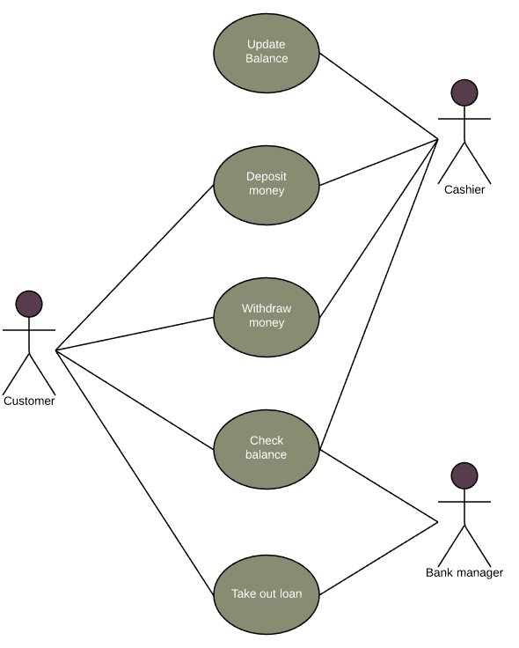

**How to make a use case diagram**

In Lucidchart, creating a use case diagram from scratch is surprisingly simple.

1. Create a use case scenario document to organize the process and all possible alternative extensions.
2. Open a blank Lucidchart document or start with a template and enable the UML shape library.
3. Select the shape you want and drag out symbols from the toolbox to the canvas
4. Then model the process flow by drawing lines between shapes while adding text.

Dive deeper into this guide on [how to draw a use case diagram in UML](https://www.lucidchart.com/pages/how-to-draw-a-class-diagram-in-UML) for additional insight. It's easy to resize and style any element. You can even import SVG shapes and Visio files for a custom solution. If you'd like to learn more about UML, check out our [What is UML](https://www.lucidchart.com/pages/what-is-UML-unified-modeling-language) tutorial.